**INT404**

**STOCK MARKET ANALYSIS AND PREDICTION**

END TERM REPORT

*by*

|  |  |  |
| --- | --- | --- |
| **Name of the student** | **Reg.No** | **Roll.No** |
| Abhishek Kumar Dwivedi | 11803826 | 26 |
| Abhishek Rana | 11803772 | 28 |
| Sai Prakash Reddy | 11803828 | 02 |

**SECTION:** K18HV



**Department of Intelligent Systems**

**School of Computer Science Engineering**

**Lovely Professional University, Jalandhar**

**April-2020**

**STUDENT DECLARATION**

This is to declare that this report has been written by us. No part of the report is copied from other sources. All information included from other sources have been duly acknowledged. We aver that if any part of the report is found to be copied, we shall take full responsibility for it.

**Name of student1:**

Abhishek Kumar Dwidedi

Reg.No: 11803826

Roll.No:26

**Name of student2:**

Abhishek Rana

Reg.No:11803772

Roll.No:28

**Name of student3:**

Sai Prakash Reddy

Reg.No:11803828

Roll.No:02

**Date: 10-April-2020**

**TABLE OF CONTENTS**

**TITLE PAGE NO.**

**1.Background and Objective …………………….... 5**

**1.1 Introduction………………………………. 5**

**1.2 Objective………………………………… 6**

**2.Description of the project……………………… 7**

**2.1 WorkFlow of the project………………………… 7**

**2.1.1 Data Description………………………….. 8**

**2.1.2 Data Normalization………………………. 8**

**2.1.3 Features………………………………… 9**

**2.1.4 Regression………………………………… 9**

**2.2 Important keywords…………………………… 10**

**2.2.1 Opening Price………………………… 10**

**2.2.2 Highest/Lowest Price of the day…………10**

**2.2.3 Volume…………………………………… 10**

**2.2.4 Adjusted closing Price………………….. 10**

**3.Implementation of scheduled work of project………… 11**

**4.Work Division…………………………………………… 14**

**5.Technologies and Framework Used…………………….14**

**6.Conclusion………………………………………………. 14**

**7.Project code Link………………………………………..14**

**BONAFIDE CERTIFICATE**

It is here been certified that this project report on “STOCK MARKET ANALYSIS AND PREDICTION” is the bonafide work of “Abhishek kumar Dwivedi,Abhishek Rana and Sai Prakash “ who carried out the project work under my supervision.

Mr.Dipen Saini

Assistant Professor

Dept: Computer Science & Engineering

LPU

Phagwara

PUNJAB

**1. Background and Objective of the Project:**

**1.1 Introduction:**

Stock Market analysis and prediction is the act of trying to determine the future value of a company stock or other financial instrument traded on an exchange.Stock Market is the important part of economy of the country and plays a vital role in the growth of the country that eventually that eventually affects the economy of the country.Both investors and industry are involved in stock market and wants to know whether some stock will rise or fall over certain period of time.The stock market is the primary source for any company to raise funds for business expansions.The value of shares of a company will depend on the demand of the company.

Due to involvement of many number of industries and companies,it contain very large sets of data from which it is difficult to extract information and analyze their trend of work manually.Stock market analysis and prediction will reveal the market patterns and predict the time to purchase stock.The successful prediction of a stock’s future price could yield significant profit.This is done using large historic market data to represent varying conditions and confirming that the time series patterns have statiscally significant predictive power for high probablity of profitable trades and high profitable returns for the competitive business investment. Another motivation for research in this field is that it possesses many theoriticl and experimental challenges.The most important of these is the Efficient Market Hypothesis whichsays that in an efficient market,stock market prices fully reflect availabe information about the market and its constituents.And also there are many lot things hidden behind this stock market which are to be known by every investor before investing.

Trade in stock market deals the movement of money of a security or stock from a trader to a buyer. This require these two parties to have the same opinion on a price. Equities (stocks or shares) present an rights interest in a specific company. Stock market participants range from small individual stock investors to larger traders investors, who can be based wherever in the world, and may contain insurance companies or pension funds, banks and hedge funds. Their buy or sell orders may execute on their behalf by a stock exchange dealer. Stock trading volume includes the number of lots bought and sold which is express in daily basis . The more trading volume of a stock is higher, the more the stock is active. Trading volume is an appreciative to price patterns in practical testing and it's additional vital than stock price.

Stock market contribution refers to the number of agents who buy and sell equity backed securities either directly or indirectly in a financial trade. Participants are normally subdivided into three distinct sectors; households, institutions, and foreign traders. Direct participation occur when any of the above entities buys or sells securities on its own behalf on a trade. Indirect participation happens when an institutional investor exchanges a stock on behalf of an individual or household. Indirect investment takes in the form of pooled investment accounts, retirement accounts, and other managed financial accounts

**1.2 Objective:**

This project will be is to create useful for investors to invest in stock market based on the various factors.The project target is to create a program that analyses previous stock data data of companies..This also includes to identify factors affecting share market.Also to generate the patterns from large data sets of data of stock market and to predict an approximate value of share price.

The main feature of this project is to generate an approximate forecasting output and create a general idea of future values based on the previous data by generating a pattern.The scope of this project does not exceed more than a generalized suggestion tool.

**2.Description of project:**

For making this project we used concepts like linear regression algorithm,pandas module for datasets,matplotlib module for predicting the stocks value through patterns.We considered the trainng dataset from the kaggle website.

**2.1 WorkFlow of the Project:**

Data

Data Normalization

Features Selection

Prediction

**2.1.1 Data Description:**

This includes the stocks of some company which has some distinguishing characteristics such as sensitivity,predictability,scalability etc,.A sample of data of stocks from kaggle website is shown below.Open,Close,Volume,Adj Volume are considered as attributes for this study.

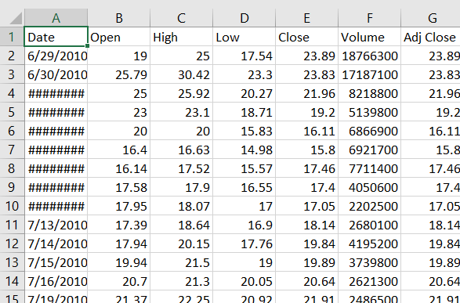

**2.1.2 Data Normalization:**

There are a couple important details to note about the way the data must be preprocessed in order to be fit into regression models. Firstly, dates are normally represented as strings of the format ”YYYY-MM- DD” when it comes to database storage. This format must be converted to a single integer in order to be used as a column in the feature matrix. This is done by using the date’s ordinal value.

**2.1.3 Features:**

Stock market close price is an important piece of information that is very useful for every short-term trader. The close prices are very important, especially for swing traders and position traders. It also has implications for practical day trading in many day trading systems. The stock market close price level provides very important information about the general mood of investors. It tells a lot about the thinking of big investors that allocate large amount of money into the stock market for their asset management purposes.

**2.1.4 Regression:**

Regression If the goal is prediction, or forecasting, or error reduction, linear regression can be used to fit a predictive model to an observed data set of y and X values. After developing such a model, if an additional value of X is then given without its accompanying value of y, the fitted model can be used to make a prediction of the value of y. Regression predicts a numerical value . Regression performs operations on a dataset where the target values have been defined already. And the result can be extended by adding new information . The relations which regression establishes between predictor and target values can make a pattern. This pattern can be used on other datasets which their target values are not known. Therefore the data needed for regression are 2 part, first section for defining model and the other for testing model. In this section we choose linear regression for our analysis. First, we divide the data into two parts of training and testing. Then we use the training section for starting analysis and defining the model.

Data

.

Testing

Training

**2.2 Important Keywords**:

These are said to be as the features of a stock market which are quite important important to be known in order to predict.

**2.2.1 Opening price**:

The opening price is the value that each share has when it opens for trading.This opening price gives a good indication of where the stock will move during the day.

**2.2.2 Highest/Lowest Price of the Day:**

The highest and the lowest price of the day are taken the day before and gives an indication of how much the shares usually move during a day and how this in the end will affect the closing price. It also shows the general cyclical movement for each share.

**2.2.3 Volume:**

Volume is one of the most basic and beneficial concepts to understand when trading stocks. Volume is defined as, “the number of shares or contracts traded in a security or an entire market during a given period of time.”

**2.2.4 Adjusted Closing Price:**

An adjusted closing price is a stock's closing price on any given day of trading that has been amended to include any distributions and corporate actions that occurred at any time prior to the next day's open. The adjusted closing price is often used when examining historical returns or performing a detailed analysis on historical returns.

**3.Implementation of scheduled work of Project:**

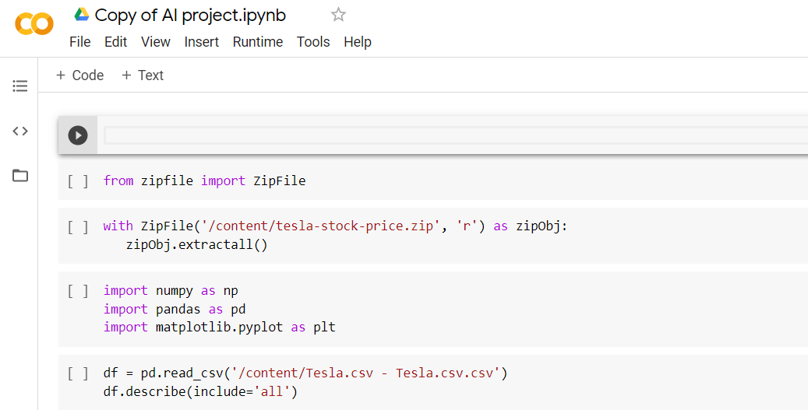All the scheduled work of the project has been carried out in python programming language using Google Colab tool.

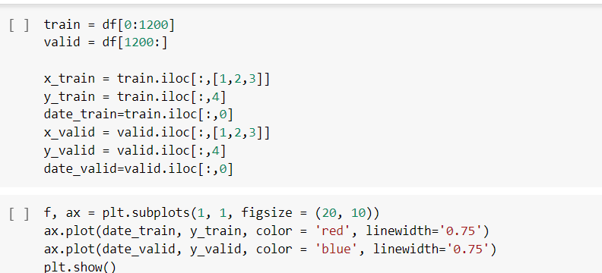Here all the required libraries(numpys for scientific computing,pandas for importing data of various formats,matplotlib to observe patterns) are being imported that are required for this project. And aslo is that we need data of stocks for this project.So,we can see above that the stock of tesla company is been imported .

From the above code we can see that the model has been trained with 1200 datasets.And using matplotlib library we tried to plot the trained data and origital data(valid).

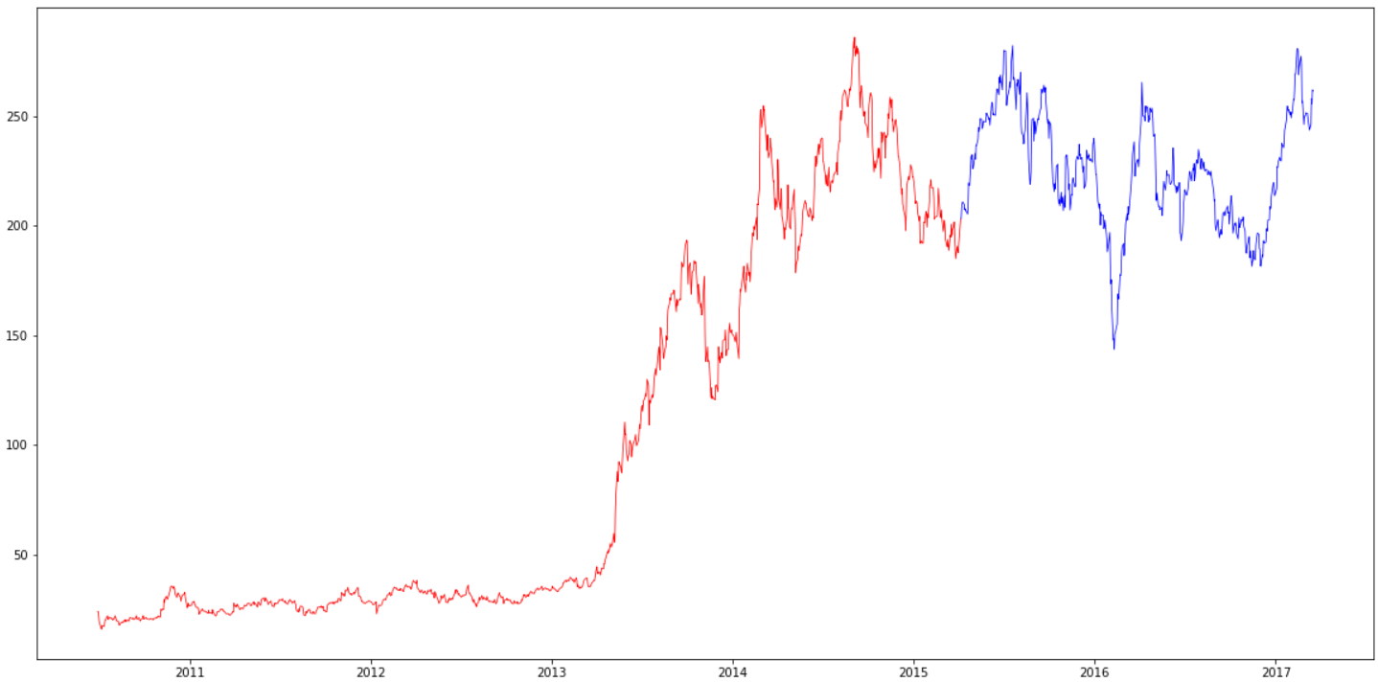This is the output for above plot between trained and original data.

The red color curve in the above graph indicates for trained Data.

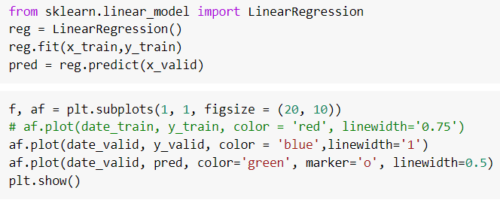 The Blue Color curve in the above graph/pattern indicates original data.

In the above code we try to import Linear Regression algorithm from sklearn library which is used to build machine learning models to the most extent.And in order to get better accurate results we try to call here ‘fit’ function and we try to plot again the data using matplot library between valid and predicted.

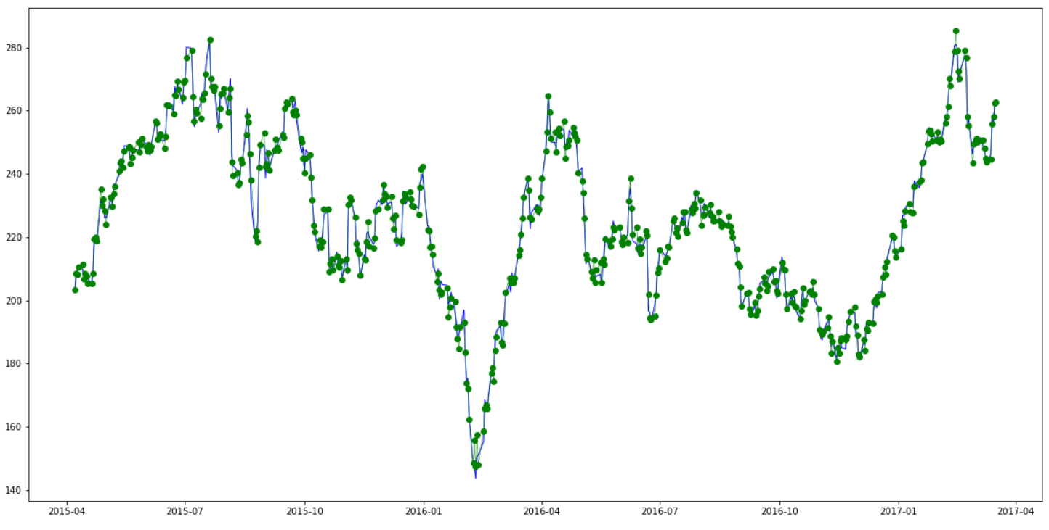 This is the graph/pattern generated between the valid data and predicted data .

The blue color curve indicates Origial/valid data.

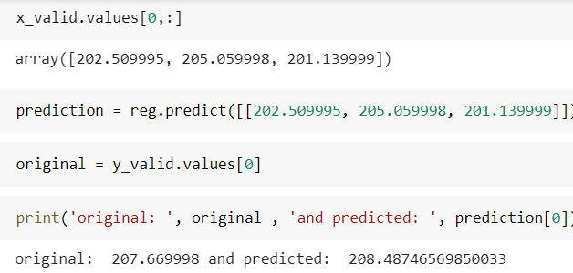 The green ones with markers ‘o’ indicates predicted values.

And finally we can see in the above code that we tried to compare whether both the original and predicted values are same or not.Finally it came to prove here that both the predicted and original values are same.

**4. Work Division:**

This project can’t be done by dividing the work of the project among us individually seprately.So,everyone revised the every concept and methodology used/related in making this project successful..

**5. Technologies and Framework used:**

When it comes to the technolgies and frameworks used in this project we choose to use python as the programming language to program the project hich quite easy to use,portable,extensible and much effiecient as of because it offers many libraries and frameworks like Tensorflow,matplotlib,pandas etc which plays a crucial role in this project.

And also we used a tool called ‘COLABORATORY’ which is also called as ‘Google Colab’ for doing this project.The thing behind using this google Colab tool is that it supports GPU which is totally for free.

**6.Conclusion:**

Finally we conclude that by this project “STOCK MARKET ANALYSIS AND PREDICTION” we came to acknowledge what actually stock market is all about.At last we came to find out that both the original and the predicted values of the stock are equal. This project really helped us in knowing how machine learning models are being trained .It also helped us in gaining immense knowledge regarding how kaggle datasets really work and how to import the kaggle datasets.It also helped in improving the skills of us by making us work with the libraries like matplotlib ,pandas and numpys.We also came to know reagrding the linear regression .At last we say that it really helped us in puttting ourselves full-pledged in applying academics practically.

**7.Project Code Link:**

<https://colab.research.google.com/drive/15edgFcwC0SHqgGcc1uPVbLoJDkv4iFTl>